**TITLE PAGE**

**EXECUTIVE SUMMARY**

Portland State Aerospace Society (PSAS) aims to design, build, and test an Electric Feed System (EFS) prototype using commercial off-the-shelf parts and in-house manufacturing. Currently, CAD designs have been finalized and selection for several key components have been chosen including the impeller design and shaft connection, motor, and design for the pump housing. This report details the requirements and selection process criteria for these components. Progress on detailed design is also discussed.

**TABLE OF CONTENTS**

**1. INTRODUCTION**

Portland State Aerospace Society (PSAS) requires a Flight-Ready Electric Feed System for their upcoming Launch Vehicle 4 (LV4). An Electric Feed System (EFS) is an electronically controlled pump system used to provide the necessary pressure to deliver liquid propellant to the engine. The EFS must be cryogenic compatible to withstand the environment that the liquid oxygen (LOX) and isopropyl alcohol (IPA) propellants create. In traditional amateur rocketry, a high pressure "blow down" system is used to deliver propellant to the engine. These systems are costly and require heavy fuel tanks causing them to be less than ideal for launch. Creating an EFS as an alternative to a pressurized tank is a challenging and innovative task that this capstone hopes to achieve.

**2. MISSION STATEMENT**

The Electric Feed System Capstone aims to provide an affordable, lightweight propulsion system technology increasing the capabilities of amateur rocketry and student education.

The final deliverable to be presented to PSAS is expected to be tested for the following: chemical compatibility, operating temperature conditions, performance and efficiency, vibrational disturbances, control signal data, and estimation of reliability. PSAS also expects complete documentation of the following: background (research done and theory of operation), CAD models for entire pump system, safety analysis and standard operating procedures for mounting and operation (including full FMEA of the pump system). Final deliverables must be within budget and completed by June 2019.

**3. PROJECT DESIGN SPECIFICATIONS (PDS)**

Portland State Aerospace Society has defined the requirements for the EFS capstone. Table B: Product Design Specifications summarizes the customer needs and their ranking of priority upon final completion. Table C: Customer Requirements and Table D: Engineering Requirements cover targets and metrics along with our verification process for achieving these.

Table B. Product Design Specification

|  |  |  |  |  |  |
| --- | --- | --- | --- | --- | --- |
| **Product Design Specification (PDS)** | | | | | |
| **Customer Need** | | | **Primary Customer** | **Priority** | **Time** |
| Must be tested with liquid Nitrogen (LN2) and isopropyl alcohol (IPA) | | | PSAS | 5 | ***** |
| Must safely keep the propellants separated at all times | | | PSAS | 5 | ***** |
| Should have embedded sensors for data acquisition | | | PSAS | 5 | ***** |
| Should have emergency shut off procedure and battery cutoff | | | PSAS | 5 | ***** |
| Should have embedded sensors for feedback, and control | | | PSAS | 4 | *** |
| Must deliver propellants at 450 PSI with NPSH of 45-100 PSI. | | | PSAS | 4 | *** |
| Must be able to operate for multiple engine test fires (≥ 10 firings) without system overhaul | | | PSAS | 3 | **** |
| Must handle launch module vibration and 10g's acceleration for 20 seconds. | | | PSAS | 3 | *** |
| Must be compatible with liquid oxygen (LOX) | | | PSAS | 3 | ***** |
| Should minimize system plumbing losses (major and minor) | | | PSAS | 2 | * |
| Must be able to be used on the PSAS engine test stand | | | PSAS | 1 | **** |

Table C. Customer Requirement

|  |  |  |  |  |  |  |  |
| --- | --- | --- | --- | --- | --- | --- | --- |
| **Customer Requirements** | | | | | | | |
| **Requirements** | | **Primary Customer** | **Metrics & Targets** | **Metric** | **Target** | **Target Basis** | **Verification** |
| Performance | LN2 Compatibity | PSAS | Must be able to safely pump liquid nitrogen | N/A | No damage | Customer Defined | Cold flow testing |
| Fluid Separation | PSAS | Must restict fluid mixing even in the event of failure | N/A | No fluid mixing | Customer Defined | Prototyping |
| Installation | Manpower to test | PSAS | Manpower | # People | 4 People | Customer Defined | Cold flow testing |
| Time to replace spare parts | PSAS | Time | Mins | 2 Hours | Team Defined | Timed after prototype built |
| Safety | LOX Safety | PSAS | Design with all chemical safety requirements via B11 Training | N/A | No LOX hazards | Customer Defined | Cold flow testing |
| Electrical Safety | PSAS | Ensure all controls systems are safe from fluids, etc. | N/A | No electrical hazards | Customer Defined | Prototyping |
| Maintenance | Minimal upkeep between test fires | PSAS | No overhaul to be required between tests | Hours of Work Rqr'd | < 4 hours | Group Defined | Testing |
| Replaceable Parts | PSAS | Readily Available Parts for replacement bearings, rings etc. | N/A | Off the Shelf Parts | Group Decision | Budget |
| Cost | Minimal production cost | PSAS | Cost | Dollars | < $9,500.00 | Customer Defined | Budget |

Table D. Engineering Requirements

|  |  |  |  |  |  |  |  |
| --- | --- | --- | --- | --- | --- | --- | --- |
| **Engineering Requirements** | | | | | | | |
| **Requirements** | | **Primary Customer** | **Metrics & Targets** | **Metric** | **Target** | **Target Basis** | **Verification** |
| Performance | EFS size | PSAS | Must be able to fit within LV4 rocket module | inches | 11.3" | Customer Defined | Airframe simulation |
| Repeatability | PSAS | Reusable for 10 test fires | # Fires | 10 | Customer Defined | Failure testing |
| Pressure Gain | PSAS | Must achieve target pressure differential | psi | 350 | Customer Defined | Cold flow testing |
| Environment | Withstand Launch Environment | PSAS | Maintain operation during launch conditions | G-force | 10 | Customer Defined | Testing |
| Withstand vibration of Airframe | PSAS | Components must be designed to avoid harmonic frequency of rocket structure | Hz | TBD | Customer Defined | Simulation |

**4. PROJECT PLANNING**

To promote progress in all divisions of the EFS design, our team was divided into two groups. The first group’s efforts were focused on finalizing design and the controls for the motor. The second group began prototyping the IPA pump housing, impeller, and motor mounts. To assure members of the team had clearly defined tasks and were able to meet deadlines, a Gantt chart was created. Table A. illustrates the timeline of completion while highlighting priority and the individuals assigned to each task.

*Table A. Electric Feed System Project Schedule*

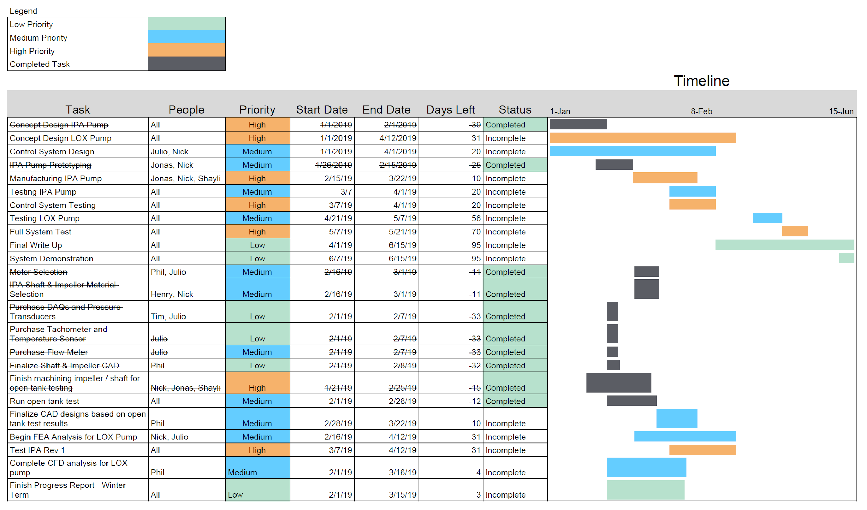

**5. EXTERNAL SEARCH**

The team’s main focus for this term was to design and test the IPA pump. In order to move forward, the IPA pump’s impeller and housing needed to be designed and a motor needed to be selected.

**5.1 IMPELLER**

In EFS pumps, a specialized impeller is required to provide high pressure gains while maintaining a low flow rate. Since this project is a part of an iterative design spanning multiple capstones, we started by looking at the previous capstone team’s work. Their research found that a Barske impeller design is the most ideal design for this application. Our team reviewed industry literature on liquid propellant rockets to verify that Barske impellers are commonly used for this application. These impellers are intentionally designed to be very inefficient. This inefficiency allows for large pressure gains, while maintaining low flow rates. The previous team also tested a variety of impeller designs with varying number of vanes. It was found that 10 vanes was the most efficient number of vanes for the pump.

**5.2 MOTOR SELECTION**

With a 30,000 RPM impeller rotation during operation, it was important that the selected motor be capable of continuously providing the necessary rotational speed without strenuous efforts. The motor also needed to quickly and accurately respond to flow characteristics via a feedback control system with integrated sensors. A previous EFS capstone design steered us towards the use of a high output RC boat brushless DC (BLDC) motors due to the relative success they achieved with this affordable motor option. Comparing system requirements showed the need for more power and controllability than previously achieved. Through fluid flow and geometric calculations, 2 kW of power, 0.6 N*m of torque, and approximately 30,000 RPM were identified as the factors for motor selection.

**5.3 PUMP HOUSING**

The most apparent feature of the previous year’s capstone that we wanted to address in our design was the pump housing. We recognized that keeping the pump housing in sections made for easy assembly and manufacturability. Our challenge was in how to reduce the weight and overall bulk of the first iteration. Although not specifically requested by PSAS, a large target for our design this year was weight reduction. We began to evaluate shape and material to determine if any sections could be altered.

**6. INTERNAL SEARCH**

During weekly meetings in the design phase, sketches and CAD models were displayed for the group to evaluate. This dedicated time gave teammates an opportunity to express concerns in design or alternatively, allowed the group to collectively agree upon the final design for any given component.

**6.1 IMPELLER**

The previous team’s impeller was manufactured using direct laser metal sintering (DLMS), an additive manufacturing process that is essentially 3D printing with metal. While this process allows for complex geometry that is often difficult or impossible to create with conventional machining processes, it cannot achieve as high of dimensional precision as machining can. Additionally, due to the nature of metal sintering, parts produced via this method are more porous than parts machined from solid billet. This became an area of concern for the team for two reasons.

First, in order for the impeller to function properly, it must have a very small clearance between the pump housing and itself. The smallest of these clearances in our design is 0.008” inches. The dimensional resolution possible with DLMS was deemed too unreliable, as the tolerance on these parts may allow the impeller to contact the wall of the impeller chamber. Further, geometric inconsistency would likely cause the impeller to become unbalanced when rotating at the 30,000 + rpm required for our design. Second, the porosity present in sintered parts was of concern considering the impeller would be rotating at high speed. While the system is only expected to transmit approximately 1.1 N-m of torque through the impeller under steady-state conditions, porosity could allow cracks to form and propagate throughout the impeller geometry under operating conditions. This would likely cause catastrophic failure in the entire rocket system should the pump fail, or fragments of material enter the fuel line. Taking these conditions into consideration, the team decided to move forward with machining the impeller in-house, using the CNC machines available on campus.

Once the impeller material and manufacturing processes had been reviewed, the team began to analyze potential designs for mating the pump shaft with the impeller. The previous team incorporated a small hub on the backside of the impeller that had a hole bored out for the pump shaft. A pin was inserted into matching cross-holes on the hub and shaft in order to connect the two components. Our team had some concern with this design and whether or not it may actually weaken the shaft, given the cross-hole diameter was relatively large compared to the shaft diameter. The reduction in shaft cross-section could introduce stress concentration problems if the inserted pin didn’t create a tight fit. The team began to analyze alternative methods to connect the shaft to the impeller.

The first alternative to using a pin was to create a sort of lobed shape on the end of the shaft, that would fit into a mating hole in the hub of the same shape. This design would allow the shaft to spin the impeller without slipping, since the shaft would only connect to the hub in one orientation. However, the team realized that this design would not prevent the impeller from sliding forward on the shaft in the axial direction, and potentially hitting the front of the impeller chamber. In order to prevent this motion, a set screw or pin would need to be incorporated, further weakening the design. Additionally, a lobed shape would introduce further complexities in the manufacturing process. A lobed shape was prefered for this design since it would remove sharp edges, and thus stress concentrations, in both the shaft and hub.

The next shaft-impeller design explored using a “keyed” shaft, where a shallow rectangular slot would be cut on the outside diameter of the shaft, along the axial direction. A matching slot would be cut inside the hub’s bore, and then a rectangular “key” would be used to fill the space between the shaft and hub, allowing the shaft to spin the impeller. We realized that this design would also require the use of a set screw to prevent the hub and shaft from separating. However, in this case a set screw could simply pass through the hub and press down on the key. Doing so would not require any additional features to be cut onto the shaft, thus maintaining the integrity of the shaft.

The challenge with the keyed design became apparent when the required machining process was taken into consideration. While a slot could easily be cut on the shaft, we would need to broach the hub in order to cut the mating slot. Broaching, a material in which small amounts of material are sheared away, requires very specific tooling to be performed inside a blind hole. Since this tooling isn’t readily available on campus, the team would need to purchase the supplies. The required tooling to broach just the hub slot would have cost around $450.00. Further, a broaching operation requires a groove to be cut deeper inside the hub bore to provide “relief” for chips formed during the broaching operation, or else the tool will bind up and break. This relief groove would require the purchase of additional tooling, and significantly weaken the hub. The team decided that prototyping this design would be too expensive, and would potentially result in a weaker assembly than the previous two potential designs (pin and lobe).

Taking into consideration the possibility of inefficient torque transmission from the motor to impeller due to various connections between different components, the team continued to look for alternative designs. The team began to explore the idea of using a solid state impeller-shaft design, in which the impeller and shaft would be one single component. Combining the shaft and impeller removes the need for a hub. Without the hub, this design would allow material reduction on the impeller itself, but would also allow the pump housing the be thinner, and thus further weight reduction. Concerns with design arose considering the change in diameter from the shaft to the outer diameter of the impeller. The largest diameter of the impeller is around 8 times larger than the shaft diameter. It was a concern that stress concentrations at the shaft-impeller interface could lead to failure. The team reviewed the torque requirements and the material properties of AL 6061-T6, and decided that the low torque would not be enough to cause failure. However, to guard against failure, a large fillet was place at the shaft-impeller interface, thus easing the transition in diameters.

The team decided that the solid state shaft-impeller design was the most promising option, and set out to verify this assumption with design scoring metrics before moving forward with prototyping.

**6.2 MOTOR SELECTION**

The requirements for shaft power led us to selecting a TP Power 4070CM as the BLDC motor for the IPA pump along with a Swordfish 200A electronic speed controller (ESC). Including the batteries and other accessories, this combination was within budget, at around $1000, and well exceeded the requirements for the IPA system. Purchasing an overpowered motor for the IPA pump increased our design efficiency by replicating the components to the cryogenic pump after testing and fine turning is completed. The use of identical motor systems for both pumps saved time and freed up focus for other components.

Safe operation is a strong requirement for the system to be considered successful. This project is to focus on designing for flight which entails autonomous operation for the EFS. When selecting the ESC, batteries, and connectors, safe autonomous operation during flight was prioritized by PSAS for the team. Gold plated, 8mm bullet connectors are found along the entire wire harness because they offer a safety factor of 1.75 against high current load damage. This minimizes the risk of meltdown and electrical fires. The batteries powering the motor have a 350A capable discharge rate which provides a 1.88 safety factor, once again, against fires due to meltdown or damage from high current demand from the motor. Lastly the Swordfish 200A ESC provides a built in water cooled case for heat dissipation and a safety factor of 1.34 against damage due to high current.

**6.3 PUMP HOUSING**

It was determined that the front case of the housing needed to be machined on three of its sides. Being limited by a three axis vertical mill, the profile of the front case was modified to have flat surface that allowed a secured set up for the side operation. CAD/CAM simulation models helped determine the dimensions of the flat without sacrificing wall thickness. Pipe thread analysis from the machinery’s handbook and past experience from team members contributed to the selection of main hardware for the housing and plumbing connections.

Alignment between front and back housing cases when assembled was a concern, and two solutions to approach this issue were evaluated. First solution was to use small dowel pins press fitted on the front case, allowing the back case to align itself to the front case when assembled. This solution was supported by previous successful results from past projects under similar conditions. The second solution was to machine oversize holes on the front case and to use precision shoulder bolts that would allow the back case to slide in place using the ground shoulder as a guide. Based on the hardware specifications provided by manufacturer, the team concluded that the precision shoulder bolts would be the best solution due to the tolerance and surface finish of the ground shoulder bolts, and the time saved by eliminating an extra machining operation.

**7. FINAL DESIGN EVALUATION**

Criteria influencing decisions made to move from design to prototyping were thoroughly evaluated and compared against customer and engineering requirements. For complex design selection, scoring matrices were used.

**7.1 IMPELLER SELECTION**

The impeller and shaft connection interface selection required careful evaluation and consideration of five key criteria. One of the highest ranking criteria was the ability of the impeller and shaft to survive up to 1.1N*m of torsional forces during high speed rotation up to 30,000 rpm. Further, the system needed to remain balanced while in motion.

The impeller and shaft needed to be machinable by the equipment and tooling that were available within the campus machine shop. These requirements were defined by the two-axis CNC lathe and the three-axis CNC mill. The cost at which we believed we could purchase the tooling for each design was also ranked. Lastly, robustness was defined as a criteria to account for the potential of cracking, bending, or other physical deformations.

These criteria along with the score for each of the four designs is shown in Table X.

Table X. Impeller-Shaft Connection Design Concept Scoring

|  |  |  |  |  |  |
| --- | --- | --- | --- | --- | --- |
| **Criteria** | Value  (1-10) | Single-Piece  (0-1) | Key Slot  (0-1) | Lobe  (0-1) | Dowel Pin  (0-1) |
| Torque Capability | 10 | 1 | 1 | 0.7 | 0.7 |
| Rotational Balance Speed | 8 | 1 | 1 | 0.6 | 0.8 |
| Machinability | 10 | 0.7 | 0.6 | 0.7 | 1 |
| Tooling Cost | 5 | 0.8 | 0.5 | 0.8 | 0.8 |
| Robustness | 7 | 1 | 0.9 | 0.6 | 0.6 |
| **Total** | **40** | **36** | **32.8** | **27** | **31.6** |

The four designs were compared against the five criteria. Each criteria was given a value of importance ranging from 1-10, with 10 being very important. Each design was ranked from 0-1 and multiplied by the criteria’s ranked value. The values in the bottom row were each compared to the maximum criteria value (40) and the highest scoring design was selected. CAD illustrations for the the key slot and single-piece shaft designs are shown in Figure 1 and Figure 2.

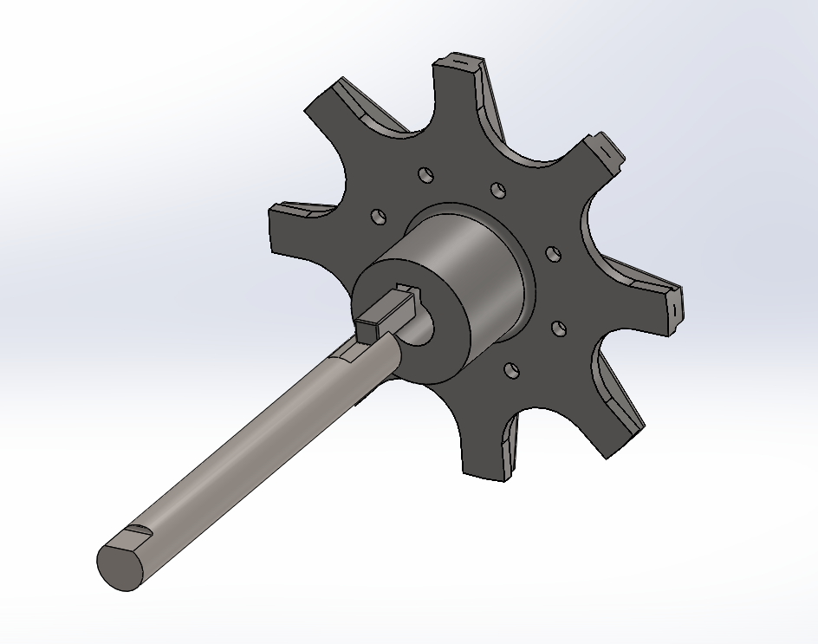 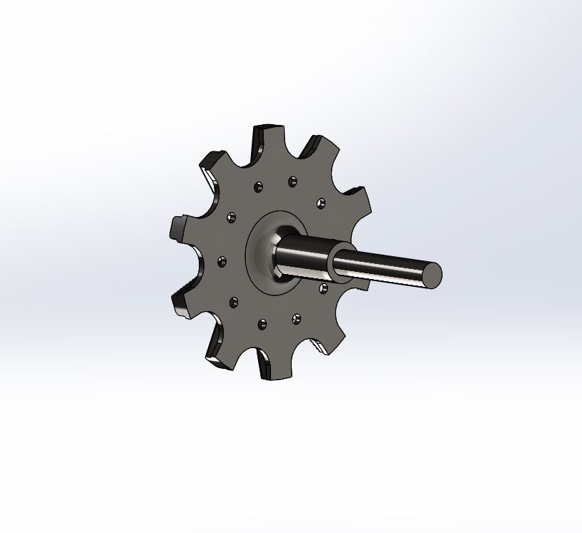

*Figure 1. Impeller with shaft and key slot Figure 2. Impeller with single-piece shaft*

The final design evaluation resulted in the selection of the single-piece shaft. It was determined that this design could be made in-house at PSU from 3” diameter, 3 ¾ long raw stock 6061-T6 aluminum. This design scored the highest against the matrix design criteria and was selected to move forward with to begin prototyping.

**7.2 MOTOR SELECTION**

This concept scoring method was also used when evaluating purchase of the motor. Criteria including torque, power, weight, and price were used when comparing motor specifications. Our final decision resulted in the selection of a TP Power Brushless 4070 CM Series Motor which has a common application in RC fast electric boating.

**7.3 PUMP HOUSING**

Following determination of impeller geometry, the team set out to select a material for the impeller of to be made out of. Primary concerns for material selection included material strength, weight, cost, and manufacturability. After careful review, the team decided to move forward with aluminum alloy 6061-T6, an alloy commonly found in aerospace applications. Due to AL 6061-T6’s relatively low cost and high machinability rating, it was an ideal candidate for prototypes. Should prototypes prove to satisfy all requirements, no additional parts would need to be manufactured since the prototypes are already made out of the design material.

**8. PROGRESS ON DESIGN**

After defining the qualitative criteria and selecting a design to pursue for the impeller, motor, and pump housing, we began to define the quantitative criteria.

**8.1 IMPELLER**

Deciding upon the final connection for the impeller and shaft proved to be one of the most challenging portions of the design. Beginning with dimensions, the quantitative criteria that were needed included impeller diameter, eye diameter, and impeller housing diameter. Considering these along with the impeller tip speed and mass flow rate, we were able to define these characteristics which are summarized in Table F.

Table F. Engineering Criterion for Impeller Characteristics

|  |  |
| --- | --- |
| Parameter | Value |
| Mass Flow Rate (kg/s) | 0.93 |
| Impeller Tip Speed (ft/s) | 211.32 |
| Pressure Gain (psi) | 343 |
| Impeller Diameter (in) | 2.682 |
| Eye Diameter (in) | 0.267 |
| Impeller Housing Diameter (in) | 3.091 |

The calculations for the specifications summarized in Table F. can be found in Appendix B.

**8.2 MOTOR SELECTION**

We determined that our motor needed to provide a minimum power output of 2.053 kW and must provide at least 0.88 N*m of torque. The calculations for determining these parameters can be found in Appendix B. We purchased our motor selection, the TP Power Brushless 4070 CM Series Motor, which provides up to 5 kW of power with a delivery of 264 amps.

**8.3 PUMP HOUSING**

Pump housing was machined out of plastic (UHMW) to provide a better understanding of machining operations and overall fit before machining the aluminum prototype. This also proved beneficial to tooling life and cost reduction, as UHMW material is easy to machine with minimum wear on cutting tools. Bore and depth dimensions as well as pipe thread type needed for the pipe to front housing case were finalized based on length of thread engagement calculations done during out internal search. An accurate analysis for the minimum thread engagement length resulted in a reduced overall thickness of the front housing case. The benefits of this analyses were more flexible tool cutting selection, faster machining time and weight reduction for the main housing case.

**9. CONCLUSION**

* Summarize the main decisions made, milestones achieved, and how close the project is to completion and relative to project plan.
* Indicate the main tasks to be done next and milestones to be achieved.
* Evaluate the current state of the product relative to the customer needs.
* State in what respects the design exceeds the needs and in what aspects the team had to make compromises regarding performance or other aspects of the design.

Be honest!

With many important smaller decisions made along the way, our biggest milestones this term were finalizing design for the impeller, the motor, and the pump housing. Pursuing a Barske impeller and a single-piece shaft connection will produce low flow, high pressure objective while also allowing for manufacturability in-house. Reducing the sections of pump housing from four sections down to two will also make a monumental difference in terms of weight reduction.

Although we are still far from completion, the rate at which we have been able to machine components for prototyping and testing has moved along quickly. We have been able to verify tool paths by machining plastic iterations of nearly all of the pump housing and have completed several impeller designs made of aluminum.

The current state of the project is near where we want it to be. Working closely with our sponsor, we have been able to communicate weekly on progress and are meeting all customer needs. Some of the bigger upcoming milestones we expect to have next term are finishing aluminum manufacturing of the pump housing to lead toward final assembly and testing. We also expect to finalize our controls and material selection for the pump components to be used in the liquid oxygen side of the system.

We have been able to exceed PSAS’s needs by having prototypes earlier than expected. Our team has shown tremendous effort in the way of producing CAD design and machining parts. Although with the great effort, we have faced the caveat of not being able to truly identify performance until testing has been completed. The only way to prove a pump’s design is to run it. We hope to begin pump testing as early as the first week of spring term.

**APPENDIX B**

We might need to save these for the next report…

: (

**Julio’s Original Words:**

Currently, we are searching for affordable cryogenic compatible pump components including seals, bearings, pressure transducers, and flow meters. Readily available cryogenic compatible components are expensive, and exceed the project’s budget. Taking cost into consideration, the team is looking into creative solutions to fulfill the system requirements. An idea under review for pressure reading currently involves using an expensive transducer connected to a standoff tube which will allow the cryogenic liquid to vaporize. In this configuration, the transducer would measure the warmer vapor pressure rather than the cooler fluid directly, in order to stay within its operating temperature range. Need to insert a source for this idea.

